OCTOBER 26TH PROGRAM
6:00 PM Set Up
6:30 PM 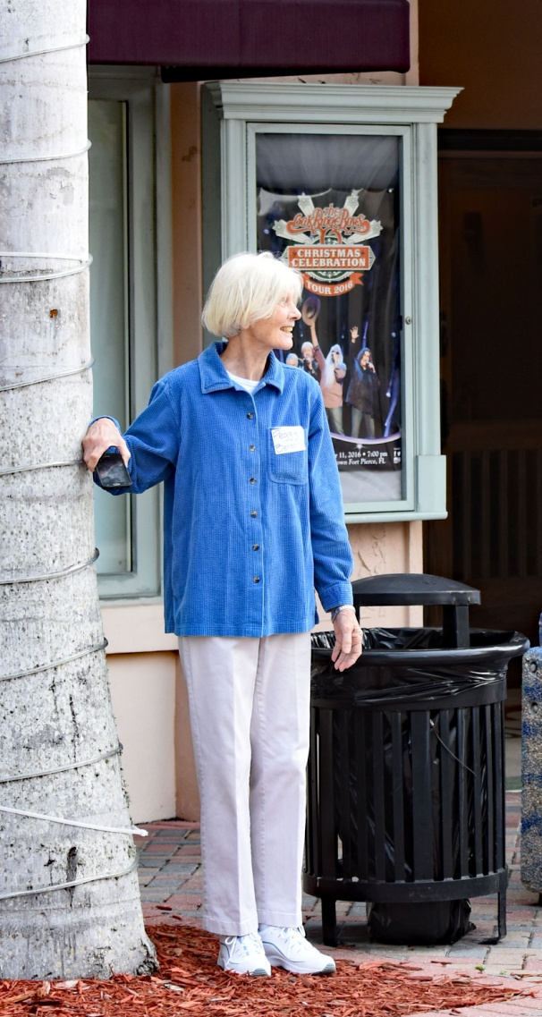 Snacks by PEGGY BENSON
6:30 PM Let’s Get to Know Each Other Mini Photo Exhibits

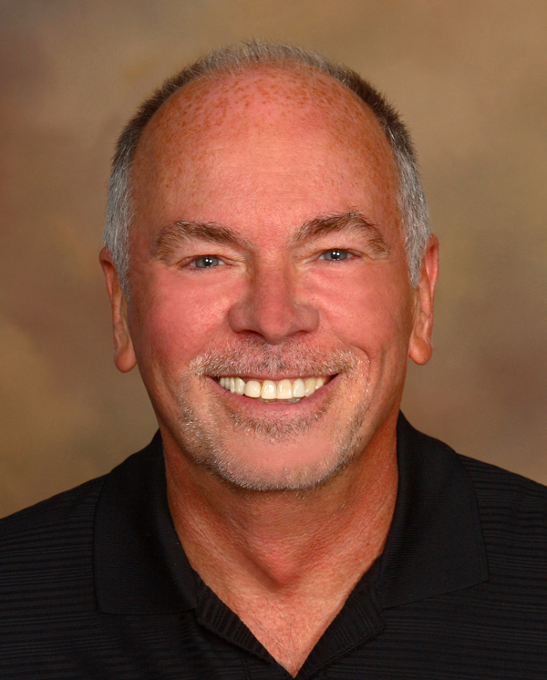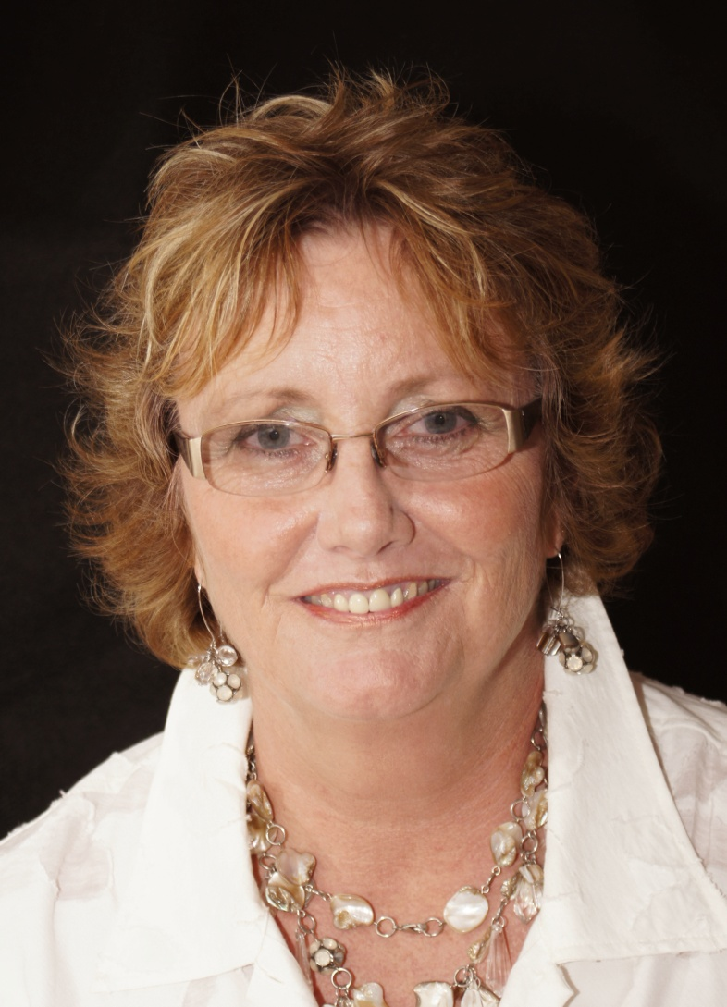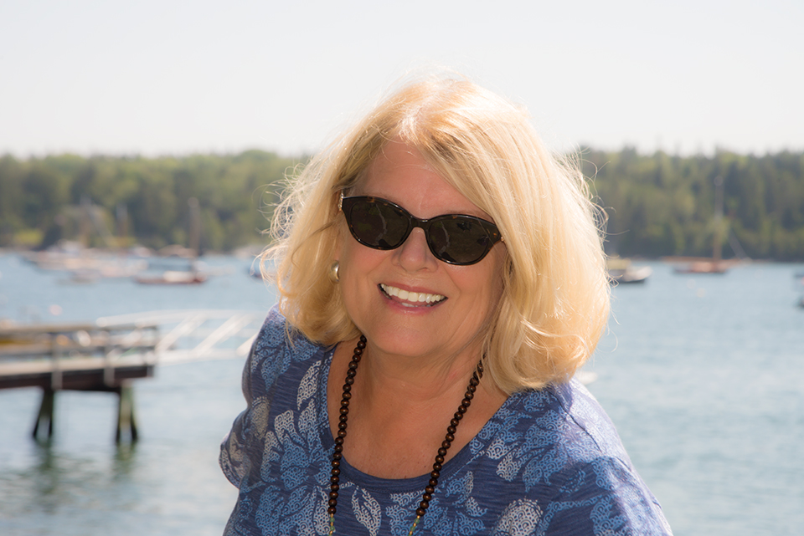
Jack Brolly Shelly Stang Mary Lou Christie
7:00 PM Announcements by President, Billy Ocker: 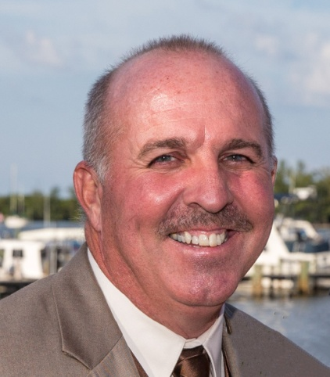 and
Presentation: HOW TO RESIZE THE DPI OF YOUR PHOTOS
Treasurer, Bobbi Whitlam, will give Treasurer’s Report. 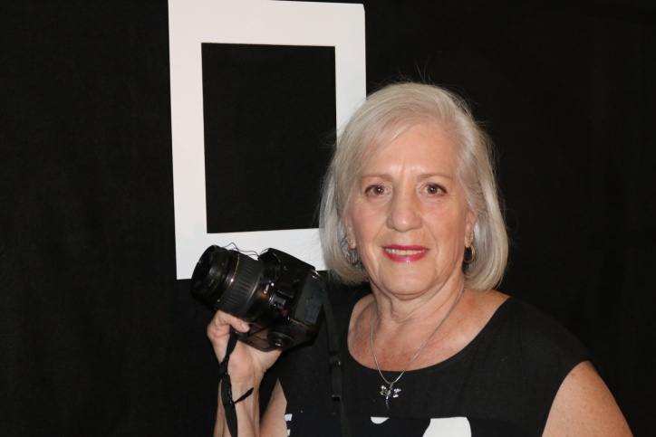
and offer a Christmas Social Sign UP

7:20 PM Members Sharing Photos Spooktacular Photos Slide Show by meb

7:30 PM PROGRAM: MARK SCHUMANN Newspapers: Black & White Film

8:30 PM Print Contest Judge Nick Binghieri 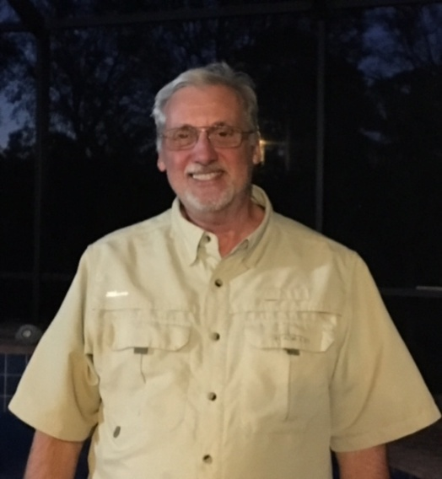Theme End of the Day

GUEST SPEAKER
MARK SCHUMANN
Newspapers: Black & White Film

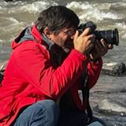

Mark Schumann is a journalist and photographer living in Taos, New Mexico. Mark and his wife, Cheri, moved from Vero Beach to New Mexico in June 2014. Mark and Cheri enjoy hiking, mountain biking and exploring New Mexico.
Mark grew up in Vero Beach, Florida, and has worked with the Vero Beach Press Journal, the Orlando Sentinel, and the St. Petersburg Times.
He owns and continues to publish InsideVero.com, and online news magazine with a companion monthly print edition. Mark has two daughters, Valerie, 30, and Kelly, 27.
(Source: Inside Vero)

