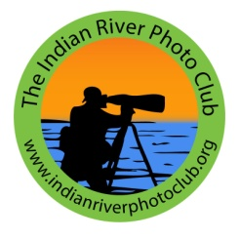
End of the Year 2018 Report
From President, Billy Ocker
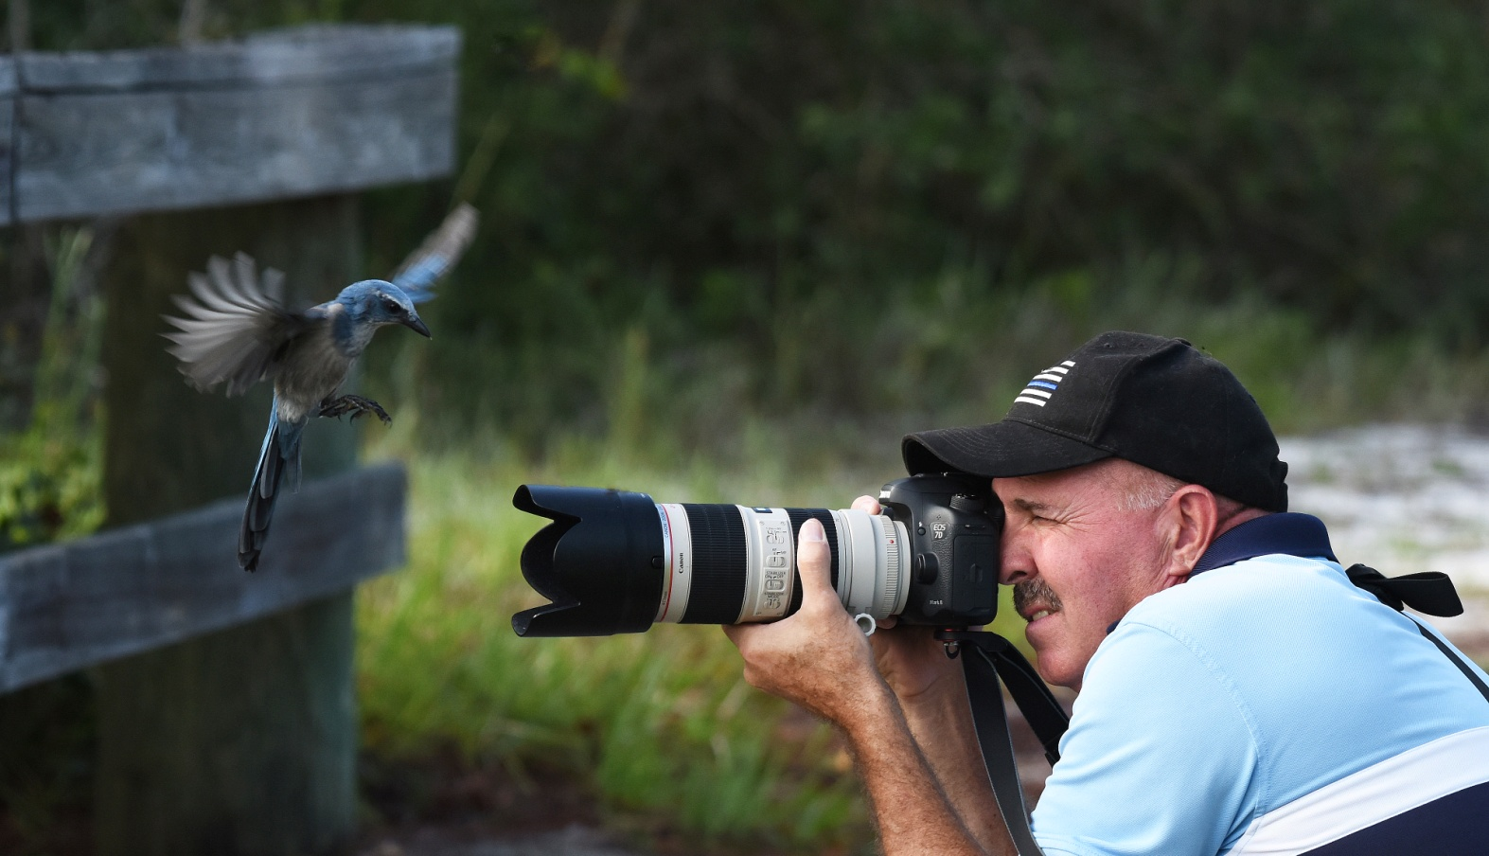

I am happy to tell you that as we end the 2018 great year we had at the Indian River Photo Club, your BOD has been working toward another superb 2019 year. All the 2019 monthly meeting speakers (listed on the club’s web site) have been scheduled, along with the member’s inspirational Mini Exhibits , and a number of Think-Outside- the-Box Activities.

We ended the year with 72 members, a large percentage of which are very active and instrumental in the daily operations of the club:

Board of Directors:
Billy Ocker, President
Nick Binghieri, VP
J.R. Williams, VP
Bobbi Whitlam, Treasurer
Tom Doyle, Secretary
Louis Ciszak, Director

Committees:
Room Set UP/Down for Meetings, Nick Binghieri
Electronics Set UP/Down for Meeting, Billy Ocker
Snacks, Etta Ocker
Greeter: Arlene Willnow
Monthly Contest Judges, Billy Ocker
Monthly Contest Manager, Patty Corapi
Program Speakers, Billy Ocker
Outside the Box, J.R. Williams and George Bollis
Advertising, Bill Conway
F3C Liaison, Bobbi Whitlam
Announcements Power Point, Mary Ester Bollis
50/50 Raffle, Tom Doyle
Museum Contest, Tom Doyle
Newsletter, Billy Ocker
Web Site Manager, Billy Ocker
Mini Exhibits, Mary Ester Bollis
Meeting Photographer (I.D. Lanyards). Bill Conway
Photo Sharing Slide Shows Coordinators, Mary Ester Bollis and J.R. Williams
BPOY Social, Etta Ocker
BPOY Intake, Bobbi Whitlam and Patty Corapi
BPOY Judges, J.R. Williams
Museum Juried Exhibit Judges, J.R. Williams

2018 Mini Photographic Exhibits by Members
Mary Lou Christie Bob Inhoff Arlene Willnow
Lee Benson Dennis Ekman Mike Ricciardi
Lou Lower Jack Sahlman David Bence
Anne Malsbary Patty Corapi Rene Donars
Ann Tatarowicz Donna Green John Waite
Bill Lord Bob Konczynski Greg McIntosh
George Bollis

2018 Speakers (See Web Site for listing of 2019 Speakers)
January: John Buck, Color, Color, Color
February: Joe Rimkus, 40 Years of Photojournalism with the Miami Herald
March: Donna Green and Louie Ciszek, What if? Why not?
April: Tom Doyle, Light: The Key to Successful Landscape Images
May: Mike Ricciardi, Underwater Photography
June: Bobbi Whitlam, Places to Photography and
J.R. Williams, Photographs from Past Decades
July: George Bollis and J.R. Williams, Titling Your Photographs
August: Patty Corapi, In and Out of the Camera
September: Chuck Palmer, Travel Photography
October: Molly Steinwald, Conservation Photography

MISC EVENTS:
February: Photographing FLORA at Odom’s Orchid Nursery
March: Photographing FAUNA at LaPorte Farms
April: Still Life Photography Seminar by David Bence
May: Okeechobee Historic Register Building Methodist Episcopal Church
And Marvin’s Scrap Yard
August: Humane Society with Hazel Lacks
September: How to Create Slide Shows Seminar with Richard Thomson
October: Night Spooktacular Photography with Billy Ocker & J.R. Williams

Looking forward to all the activities planned for 2019.

Respectfully submitted,

Billy Ocker, President

